(Internal Only)

Background:
This document is helpful when we have created the SharePoint servers in the Test-Portal AWS account with our Terraform script, but our SharePoint team is unable to do RDP and get Administrator access to those machines.

Root cause:
What is expected and needs to be fixed:
If we see our Terraform script below, the userdata.tpl should add those machines into Domain and add the users/groups into Administrator group. And those users should get remote access to those machines. But this does not work properly, it might be either the script itself not accurate or failed to run or the mentioned group/user are not configured in AD, or the users are not the members of the AD groups.
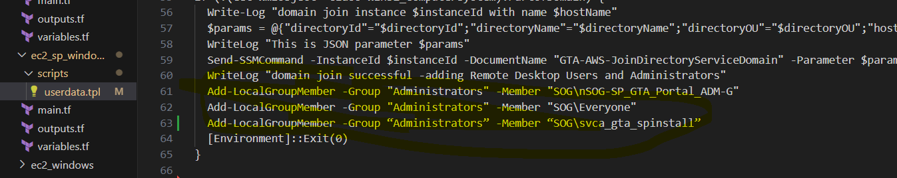
"Userdata script is stored at : C:\Windows\system32\config\systemprofile\AppData\Local\Temp\
C:\UserDataLog

Work around:
To fix this as an interim solution, we can approach in any of the following (4) ways (As we do not have RDP access, we need to access via the AWS console):
- Editing the userdata.tpl file from EC2 settings:
As we see the script failed, so if we stop the instance, and then edit the script by taking those three lines outside the if condition, then it should be working as expected. (shown below)
Add-LocalGroupMember -Group “Administrators” -Member “SOG\nSOG-SP_GTA_Portal_ADM-G”
Add-LocalGroupMember -Group “Administrators” -Member “SOG\Everyone”
Add-LocalGroupMember -Group “Administrators” -Member “SOG\svca_gta_spinstall
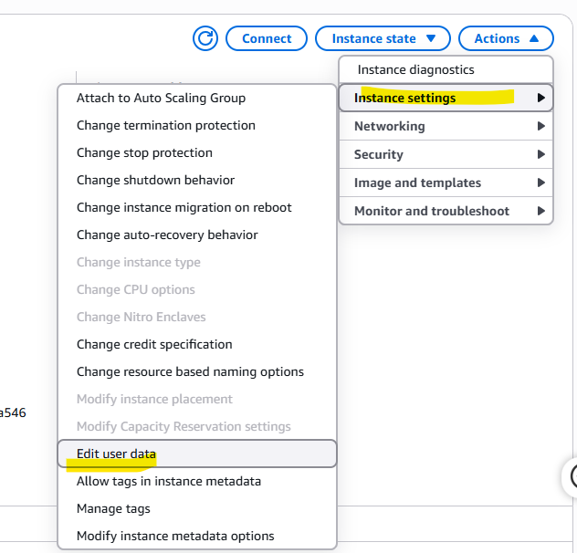
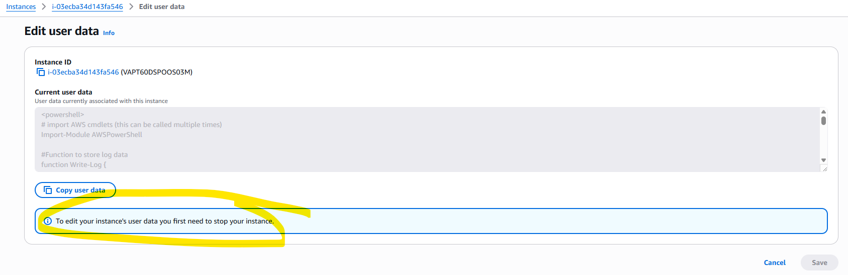
After changing the file, if we start again, it should the effected, to check that impact we can see the logs and user groups.
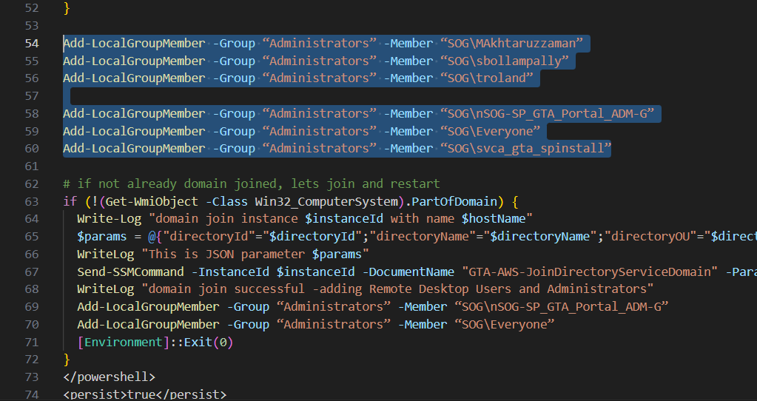

- Connect with CLI (session commands):
Please follow the screenshot below.
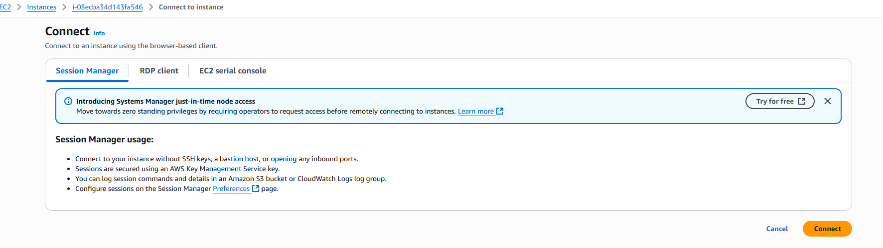

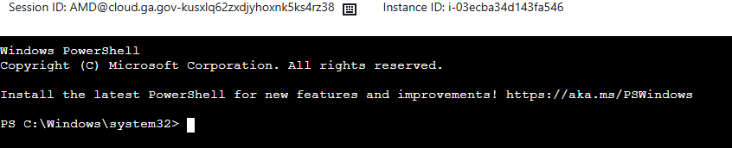

<< Srikant did that, he will paste those commands here>>

- Connect with GUI and Run from PowerShell command:
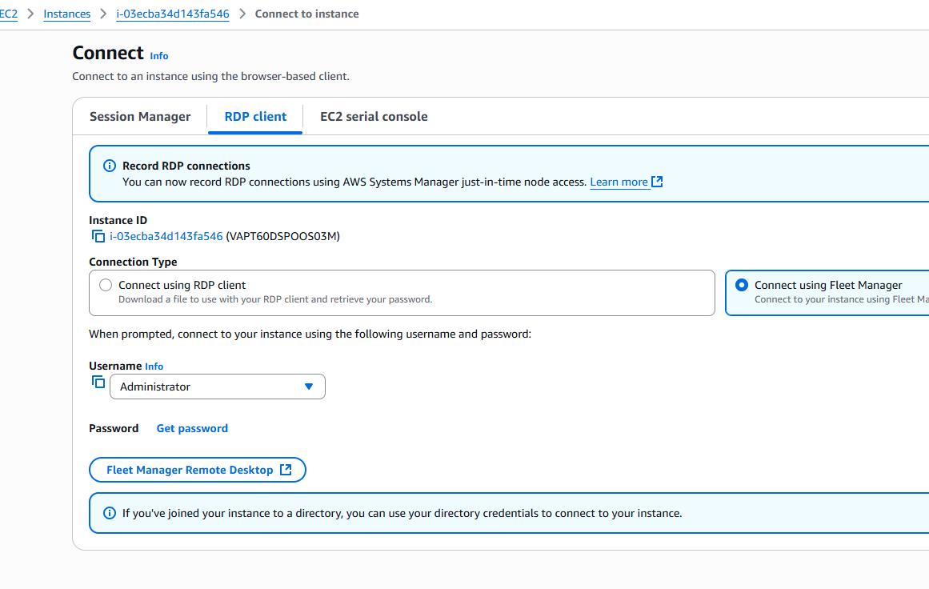
Systems Manager>Fleet Manager>Remote desktop
Or above path
Then,
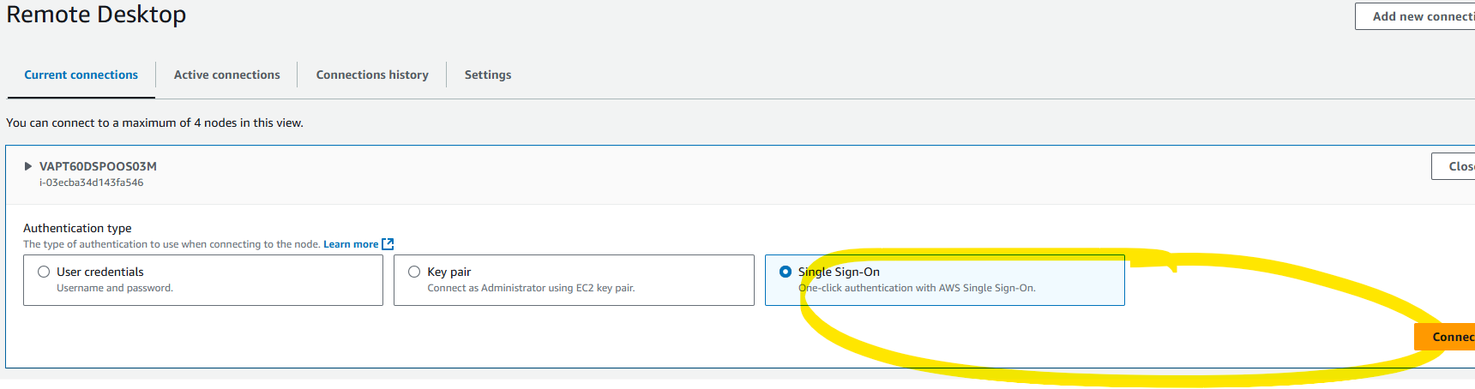

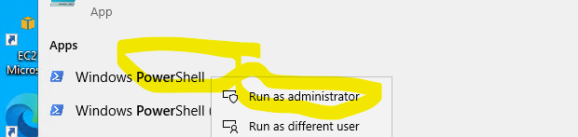
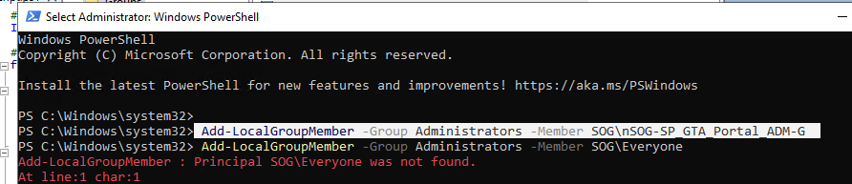
Add-LocalGroupMember -Group “Administrators” -Member “SOG\nSOG-SP_GTA_Portal_ADM-G”
Add-LocalGroupMember -Group “Administrators” -Member “SOG\Everyone”
Add-LocalGroupMember -Group “Administrators” -Member “SOG\svca_gta_spinstall”

If you want to run this command for some specific users, then

Add-LocalGroupMember -Group “Administrators” -Member “SOG\MAkhtaruzzaman”
Add-LocalGroupMember -Group “Administrators” -Member “SOG\sbollampally”
Add-LocalGroupMember -Group “Administrators” -Member “SOG\troland”

- Connect with GUI and Run from the user window: Please follow the below shown.
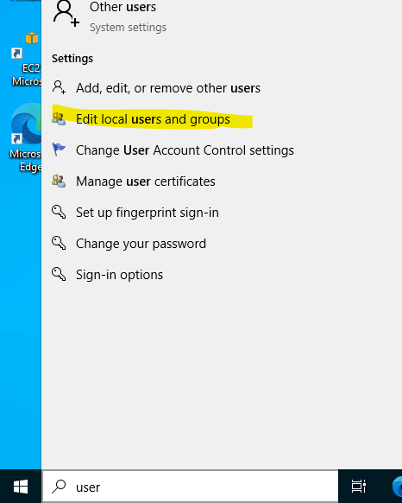

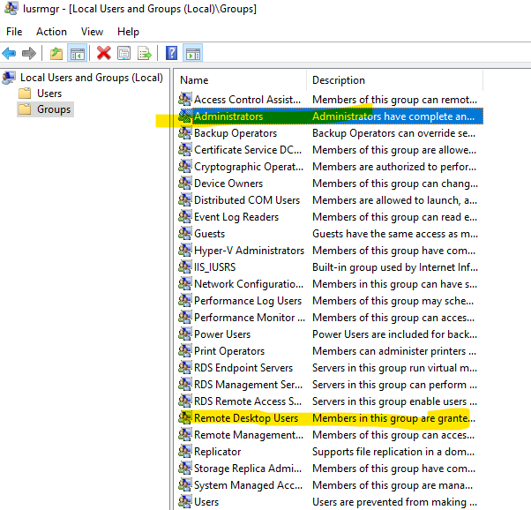
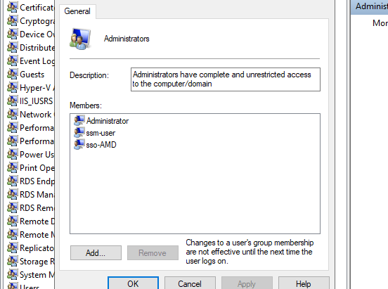

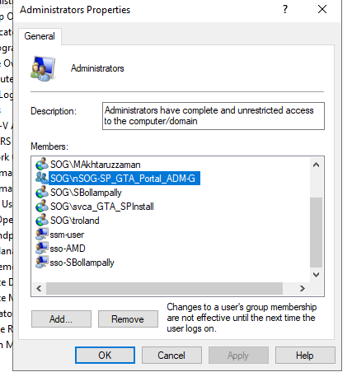
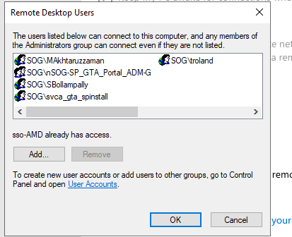
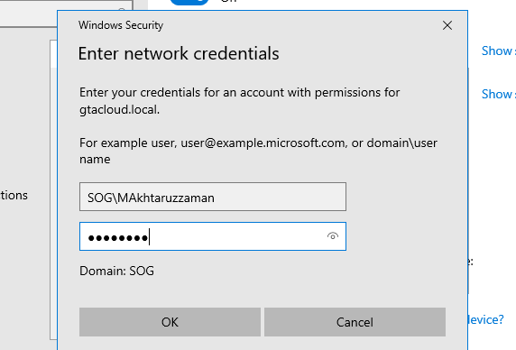
Finally, you need to provide your own credentials, if you have the access.

Conclusion:
We hope this will solve your problem. Please investigate more to get this fixed and let the AD folks know if you need any further support on this.
Additionally, if they have any issue with the other Local drives like D, E, F, and G. we might need it to format those as they might have the access issue.

